LAB 12: Common Base BJT Characteristics

**Date: 12-03-2021 Reg.#: 2019-EE-360**

**2019-EE-364**

**2019-EE-366**

## OBJECTIVES:

## To understand the concept of transistor biasing.

* To implement the base biasing scheme for BJT.
* To plot the output characteristics of the common base BJT.
* To understand the concept of dc load line for common base biased configuration.

## SUGGESTED READING:

* Class Lectures
* [Chapter 7: “***Bipolar Junction Transistors***”, *introductory Electronic Devices and Circuits by Robert T. Paynter.*](http://arduino.cc/en/Guide/HomePage)
* Datasheet: 2N3904 NPN bipolar Junction Transistor

## EQUIPMENT AND COMPONENTS:

* Basic Circuits Training Board
* 2N3904 Transistor
* Jumper Wires
* Palm Scope / DMM
* Resistors
* DC Power Supply

---------------------------------------------------------------------------------------------------------------------

## Transistors as Amplifiers:

## Transistors are non-linear three terminal semi-conductor devices used to amplify a current or voltage signal. Transistor amplifiers are grouped into one of three basic circuit configurations depending on which transistor element is common to input and output signal circuits.

1. Common Base
2. Common Emitter
3. Common Collector

Each circuit configuration has its own characteristics and, therefore, its own applications.

Transistors are operated in three different regions i.e. active, saturation and cut-off region. A transistor is normally operated in its active region. In its active region, a transistor exhibits those normal properties (transistor action) in which emitter-base junction is forward biased and collector-base junction is reverse biased. In saturation region, both emitter to base and collector to base junction are forward biased. In cut-off region, both emitter-base and collector-base junction are reverse biased. **The saturation and cut-off region of a transistor are useful in digital circuit applications where they perform the function of switching.** Later, we will see how a transistor can be used as a switch.

## BJT Biasing

A bias circuit allows the operating conditions of a transistor to be defined, so that it will operate over a pre-determined range. This is normally achieved by applying a small fixed dc voltage to the input terminals of a transistor. The quiescent point/operating point (Q-point) refers to the DC conditions of the circuit with the presence of any dc input. If the Q-point of the circuit lies mid-way on the load line, the circuit is said to be mid-point biased.

## Biasing of common base BJT

The biasing of common base NPN bipolar junction transistor is shown below. The external bias resistors are connected to the collector and emitter respectively. The base is common to both emitter and collector terminal. The input current is emitter current and the input voltage is base emitter voltage which is normally 0.7 V for silicon transistor. The output current is collector current and the output voltage is VCB.

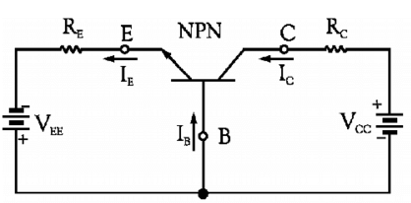

*Fig. Common base biased configuration*

## Input and output current

The input current can be obtained by applying KVL to the input side. Applying the KVL to input gives the following equation.

$$\left|V_{EE}\right|=I_{E}R_{E}+V_{BE}$$

Remember to use the absolute value for the dc source VEE to satisfy the equations.

From this equation, the input current can be calculated as

$$I_{E}=\frac{\left|V_{EE}\right|-V_{BE}}{R_{E}}$$

As the output current is related by the following expression

$$I_{c}={αI}_{E}$$

where $α≈1$.

## Input and output voltage

The input voltage is base-emitter voltage which is approximately 0.7 V for silicon transistor. The output voltage can be calculated by applying KVL to the output side of the circuit diagram.

$$V_{CB}-V_{CC}+I_{C}R_{C}=0$$

$$V_{CB}=V_{CC}-I_{C}R_{C}$$

The output voltage can be simply be interpreted as the voltage equal to the supply voltage Vcc minus the voltage that has dropped across the external bias collector resistance Rc.

## Output characteristics and load line

The output characteristics are plotted between the output current and output voltage for fixed values of input current.

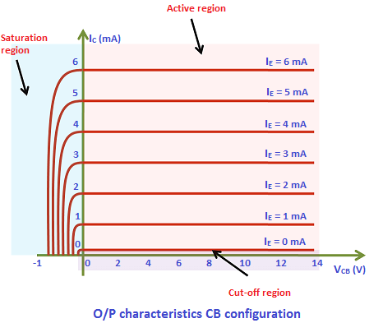

The blue region indicates the saturation region where the collector current is maximum, and its value is Vcc/Rc and the output voltage at the collector-base junction $V_{CB}=0$. As we already know that in saturation region, both the emitter-base and collector-base junctions are forward biased. As the collector current is maximum which means that the emitter current is also maximum as they are related by the factor α which is approximately equal to 1 which confirms the fact that the emitter-base junction is forward biased. As the output voltage $V_{CB}$ is equal to zero which corresponds to the fact that the collector-base junction is no more reverse biased.

When the output current is zero, which means that the emitter current is also zero. When emitter current is zero, it corresponds to the fact that the emitter-base junction is reverse biased. At the output, $V_{CB}$ is exactly equal to the supply voltage $V_{CC}$, which implies that the collector-base junction is reverse biased too. Recall that a transistor is said to be in a cut-off state when both the emitter-base and collector-base junctions are operating in the reverse biased mode. In the above figure, the region below $I_{E}=0$ corresponds to the cut-off region.

The active region is shown in the shaded red area. The active region represents the normal properties of a transistor action, in which the emitter-base junction is forward biased and the collector-base junction is reverse biased.

From the output equation, the collector current can be written in this form as below

$$I_{C}=-\frac{1}{R_{C}}V_{CB}+\frac{V_{CC}}{R_{C}}$$

If the output current and output voltage are regarded as variables and Vcc and Rc are regarded as constants, the above equation represents the equation of a straight line. When plotted on a set of Ic-VCB axes, the line has a slope of $-1/{R_{C}}$ and it intercepts the Ic-axis at Vcc/Rc. It is the line through all possible combinations of output voltage and output current. The actual bias point must be a point lying somewhere on the line. The precise location of the point is determined by the input current.

The point where the load line intercepts the VCB-axis can be found by setting IC = 0 in the above equation and solving for VCB. Similarly, the point where the load line intercepts the Ic-axis can be found by setting VCB = 0 and solving for Ic. Thus, the load line can be drawn by drawing a line through the two points VCB = 0, Ic = Vcc/Rc and Ic = 0, VCB = Vcc.

## Procedure

* Connect the circuit as shown in the diagram and set the voltage Vcc and VEE.
* Measure the collector current with the help of the ammeter and record the reading in the table.
* Measure the output voltage VCE with a voltmeter and record the value in the table.
* Calculate the error percentage between the calculated and measured values.
* Now fix the supply voltage Vcc and external bias resistors and vary the supply voltage VEE to plot the dc load line for at least 5 different operating points/Q-points.

## Observations

***Simulation and Results:***

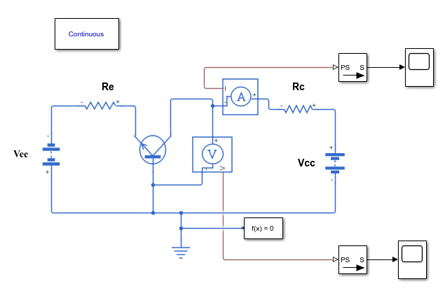

Vcc = __10 V____, Rc = ___1.12 kΩ_______, RE = ____1 kΩ______

|  |  |  |  |
| --- | --- | --- | --- |
| 3 V | Calculated | Measured | Error Percentage |
| Output current (IC) | 2.3 mA | 2 mA | 13 % |
| Output voltage (VCB) | 7.4 V | 7.3 V | 2.6 % |

|  |  |  |  |
| --- | --- | --- | --- |
| 4V | Calculated | Measured | Error Percentage |
| Output current (IC) | 3.3 mA | 2.88 mA | 13 % |
| Output voltage (VCB) | 6.3 V | 7.1 V | 13 % |

|  |  |  |  |
| --- | --- | --- | --- |
|  | Calculated | Measured | Error Percentage |
| Output current (IC) | 4.3 mA | 3.8 mA | 13 % |
| Output voltage (VCB) | 5.18 V | 6.2 V | 20 % |

|  |  |  |  |
| --- | --- | --- | --- |
|  | Calculated | Measured | Error Percentage |
| Output current (IC) | 5.3 mA | 4.6 mA | 13 % |
| Output voltage (VCB) | 4.1 V | 5.3 V | 32 % |

|  |  |  |  |
| --- | --- | --- | --- |
|  | Calculated | Measured | Error Percentage |
| Output current (IC) | 6.3 mA | 5.5 mA | 13 % |
| Output voltage (VCB) | 2.9 V | 4.45 V | 50 % |

***Hardware Results:***

Vcc = ______10V___, Rc = ____1.12 kΩ_____, RE = ____1 kΩ______

|  |  |  |  |
| --- | --- | --- | --- |
|  | Calculated | Measured | Error Percentage |
| Output current (IC) | 2.3 mA | 2.2 mA | 4.3 % |
| Output voltage (VCB) | 7.4 V | 7.2 V | 2.5 % |

|  |  |  |  |
| --- | --- | --- | --- |
| V | Calculated | Measured | Error Percentage |
| Output current (IC) | 3.3 mA | 3.1 mA | 6 % |
| Output voltage (VCB) | 6.3 V | 6.1 V | 3.2 % |

|  |  |  |  |
| --- | --- | --- | --- |
| 5 V | Calculated | Measured | Error Percentage |
| Output current (IC) | 4.3 mA | 4.2 mA | 2.3 % |
| Output voltage (VCB) | 5.2 V | 5.3 V | 1.8 % |

|  |  |  |  |
| --- | --- | --- | --- |
| 6 V | Calculated | Measured | Error Percentage |
| Output current (IC) | 5.3 mA | 5.1 mA | 3.7 % |
| Output voltage (VCB) | 4.06 V | 4.01 V | 1.3 % |

|  |  |  |  |
| --- | --- | --- | --- |
| 7 V | Calculated | Measured | Error Percentage |
| Output current (IC) | 6.3 mA | 6.1 mA | 3.2 % |
| Output voltage (VCB) | 2.9 V | 2.8 V | 5.4 % |

## Tasks

* Perform all the calculations for the output current and output voltage on separate pages.
* Plot the output characteristics of the common base biased configuration MS EXCEL. Plot both the measured and calculated values on the same graph.

# REVIEW QUESTIONS:

Q: What is the purpose of biasing a BJT?

Transistors are voltage barrier devices, to operate they require proper voltage on the input(base)and on the output (collector).

The goal of Transistor Biasing is to establish a known quiescent operating point, or Q-point for the bipolar transistor to work efficiently and produce an undistorted output signal

Q: How it can be made sure that the CB circuit is biased at the mid-point?

If a  transistor is used as an amplifier, it is always designed for midpoint bias. The reason is that midpoint biasing allows optimum operation of the amplifier. In other words, midpoint biasing provides the largest possible output.

Q: Why do we require the transistor to be mid-point biased?

When a transistor is used as an amplifier, it is always designed for midpoint bias. The reason is that midpoint biasing allows optimum operation of the amplifier. In other words, midpoint biasing provides the largest possible output.

Q: In which regions, a BJT can be operated?

 There are three operating regions of a BJT, cutoff region, saturation region, and active region

Q: How the emitter-base & collector-base junctions are biased in active region, saturation region and cut-off region?

|  |  |  |
| --- | --- | --- |
| **Operating mode of BJT** | **Emitter-base junction** | **Collector-base junction** |
| Active region | Forward biased | Revers biased |
| Saturation region | Forward biased | Forward biased |
| Cutt-off region | Revers biased | Revers biased |

**MATLAB Circuit:**

